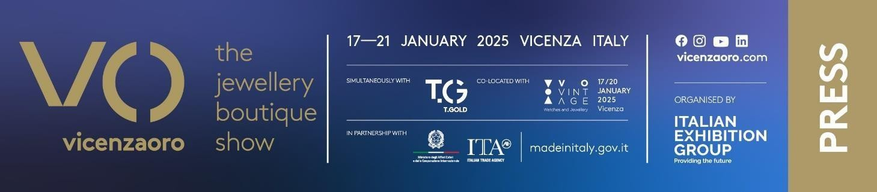

Final press release (English translation)

IEG: VICENZAORO JANUARY CONFIRMS ITS SUCCESS:
INTERNATIONAL BUSINESS AND NETWORKING PLATFORM

- 1,300 brands, increase in international attendance and buyers from 145 countries
- Contemporaneity with T.Gold
- Focus on young generations, sustainability and technological innovation
- Expansion work at Vicenza Expo is progressing
- Eight new international events in 2025 for the gold and jewellery sector
vicenzaoro.com | #craftingthefuture

Vicenza (Italy), 21st January 2025 – Concrete business, solid design, networking and debate with global industry players, constant relations with stakeholders, focus on trends. And all with the simultaneous continuity - in full respect of the time schedule - of the Expo Centre’s expansion works with no impact whatsoever on companies and buyers.

Vicenzaoro January 2025, the event of reference for the global jewellery industry and the starting point of the sector's global calendar. The edition not only confirmed last year's exceptional numbers, it also touched the international dimension record: in fact, foreign visitation – greater than that of Italians – reached the extraordinary participation number of 145 countries from all over the world, with Turkey, the United States, Germany, Spain and Greece in the lead and interesting increases in countries such as North Korea and Australia.

“We have won the internationality challenge,” commented Corrado Peraboni, CEO of Italian Exhibition Group, in regard to Vicenzaoro January 2025. “Several years ago, we decided to develop our leading products abroad. A successful strategy that has decisively increased foreign visitation at our most important events in Italy.”

Matteo Farsura, head of IEG's gold and jewellery division, underlined: “With 1,300 brands and the involvement of the entire jewellery supply chain, from technologies to haute joaillerie, Vicenzaoro confirms its position as a global platform of reference, favouring dialogue among the different segments to meet the needs of the various markets. In parallel, with the involvement of 650 young students on the opening day and further in-depth discussions within the full programme, together with the main trade associations, the centrality of training and generational turnover was reaffirmed.»
A sector that, in the specifics of Made in Italy, is continuing its positive trend: in the first 10 months of 2024, the jewellery industry's revenues were up 5.8% (Istat data) with exports more dynamic than the domestic market (+7.2% vs +3.0%).

Thanks to the development of tailor-made contents in a highly energetic atmosphere and to an elegant and distinctive look & feel, the sector’s community perceives Vicenzaoro as a fundamental reference point for the development of business, relations and knowledge. Just think of the authoritative look at the future through Trendvision Jewellery + Forecasting, IEG's independent observatory, of the topics connected to technology and ESG at the centre of debate with events organised by CIBJO and the Jewellery Technology Forum promoted by Legor, prior to September’s debut of The Vicenza Symposium, an international scientific event on the theme of technologies, metals and urgencies that link jewellery and fashion.

Vicenzaoro was held in conjunction with T.Gold, which showcased the excellence of the sector's technologies (a T.Gold that, thanks to the Expo Centre’s expansion, will be staged inside the Vicenzaoro areas as of the second half of 2026), and VO Vintage, the fine vintage watch show, and the collaboration with Vicenza Municipality at VIOFF, the experiential off-show event that involved guests from all over the world: offer completeness, business centrality and global media resonance once again made this event the beating heart of world jewellery and goldsmithing.

A “rhythm” of business and innovation that never stops but continues for twelve months a year in a unicum of Italian Exhibition Group appointments and jewellery&fashion projects all over the world. IEG's agenda will see OROAREZZO in May, SIJE in Singapore in July, Vicenzaoro September at the end of the summer (and the return of VO'Clock Privé) preceded by the new Vicenza Symposium, the Valenza Gem Forum in October, JGTD in Dubai in November, and the Italian Jewellery Summit in Arezzo in December.

IEG thanks all the companies that contributed to the success of Vicenzaoro January 2025. And all the partners: the Ministry of Enterprise and Made in Italy, ITA – the Agency for the promotion and internationalisation of Italian companies abroad, Confindustria Federorafi, Confartigianato Orafi, Confcommercio Federpreziosi, CNA Orafi, Club degli Orafi Italia, Confimi Industria Gold and Silversmith Category, Assogemme, Assocoral and AFEMO – Italian Association of Jewellery Machinery Manufacturers and Exporters. Authoritative international organizations also contribute to the show’s agenda: from CIBJO - World Jewellery Confederation, which promotes the jewellery supply chain’s economic and social sustainability, to GJEPC India - Gem and Jewellery Export Promotion Council, HKJJA - Hong Kong Jewellery & Jade Manufacturers Association, and Francéclat, to mention but a few.

Photos can be downloaded at THIS LINK

PRESS CONTACT IEG / VO VINTAGE 2025:
head of media relation & corporate communication: Elisabetta Vitali; press office manager: Marco Forcellini, Pier Francesco Belliini; press office coordinator: Luca Paganin; international press office coordinator: Silvia Giorgi; press office specialist: Mirko Malgieri media@iegexpo.it;

MEDIA AGENCY VO VINTAGE 2025: Adnkronos Comunicazione
Bruno Rizzotti: 393 9521436, bruno.rizzotti@adnkronos.com;
Enrico Bellinelli: 334 5717790, enrico.bellinelli.professional@adnkronos.com;
Fabio Valli: 344 1281966, fabio.valli@adnkronos.com;
Alessandra Paladini: 331 907 89 81, alessandra.paladini@adnkronos.com

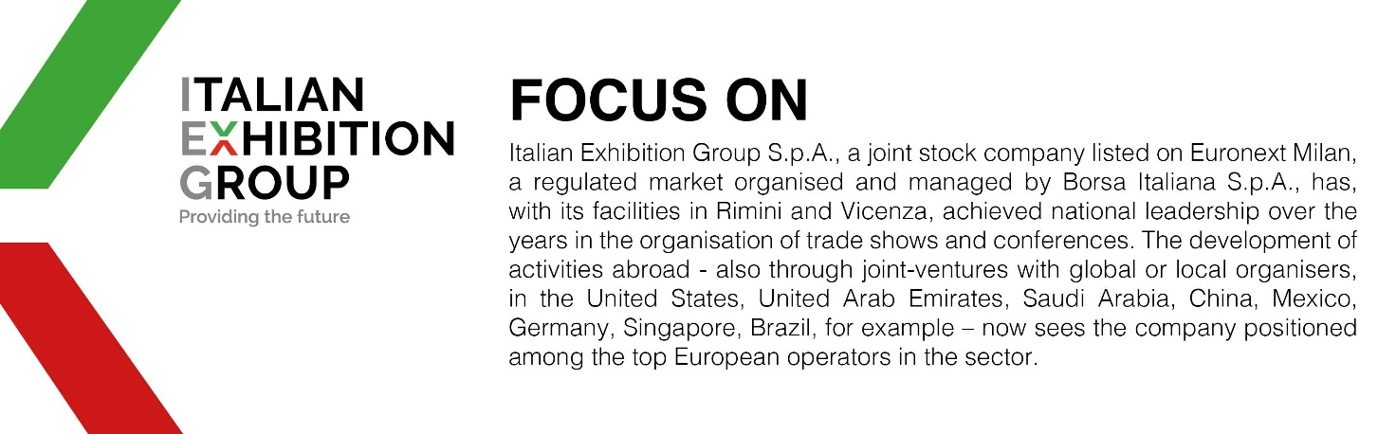

This press release contains forecasted elements and estimations that reflect current management opinions (“forward-looking statements”) especially regarding future managerial performances, investments, cash flow trends and financial organization evolution. By nature, forward-looking statements have an element of risk and uncertainty since they depend on future events. The effective results may therefore differ, even significantly, to those announced due to multiple factors including, merely by way of example: the catering market’s foreign trends and tourist flows in Italy, market trends in the gold-jewelry industry and in the green economy; developments in the price of raw materials; general macro-economic conditions; geo-political factors and changes in the legislative framework. Furthermore, the information in this press release does not claim to be complete, nor has it been verified by independent third parties. The forecasts, estimations and objectives presented herein are based on information available to the Company at the press release issue date

